**VPC:**Virtual private cloud

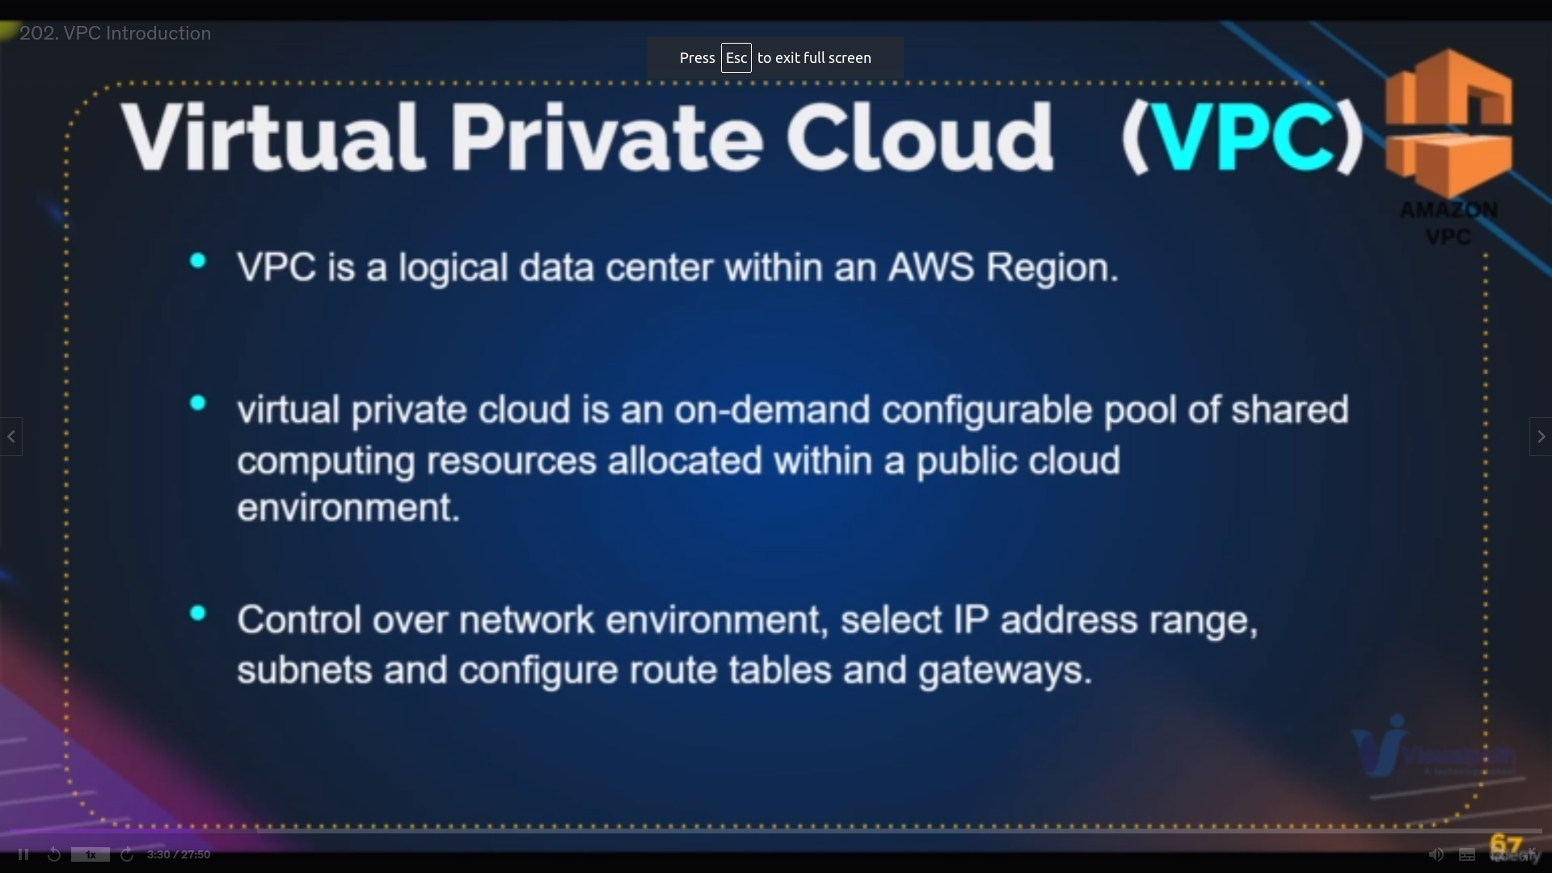we can create our own cloud where we can give who can enter and who cannot

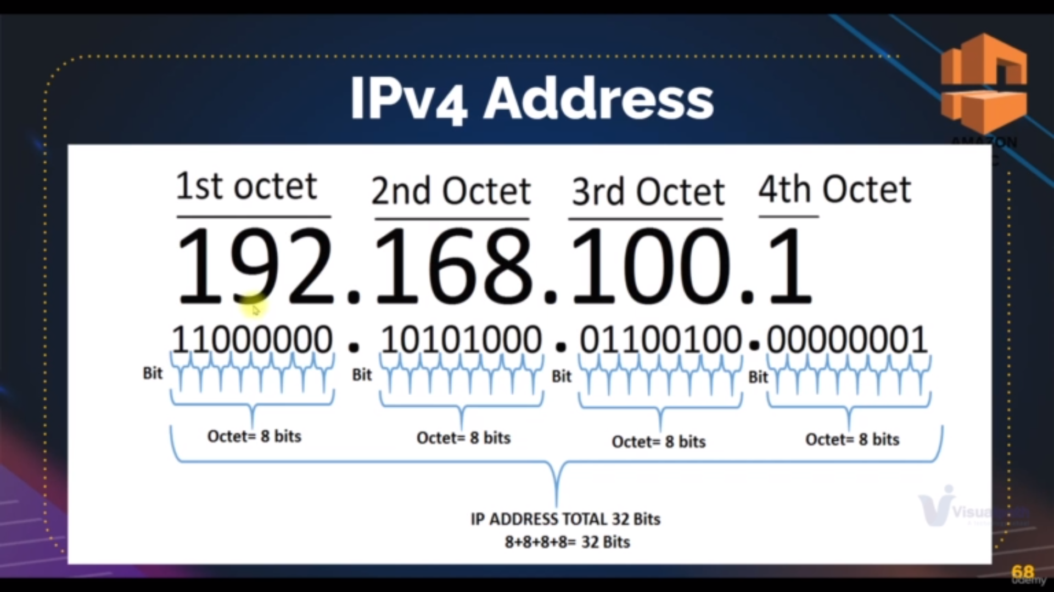division of ipv4

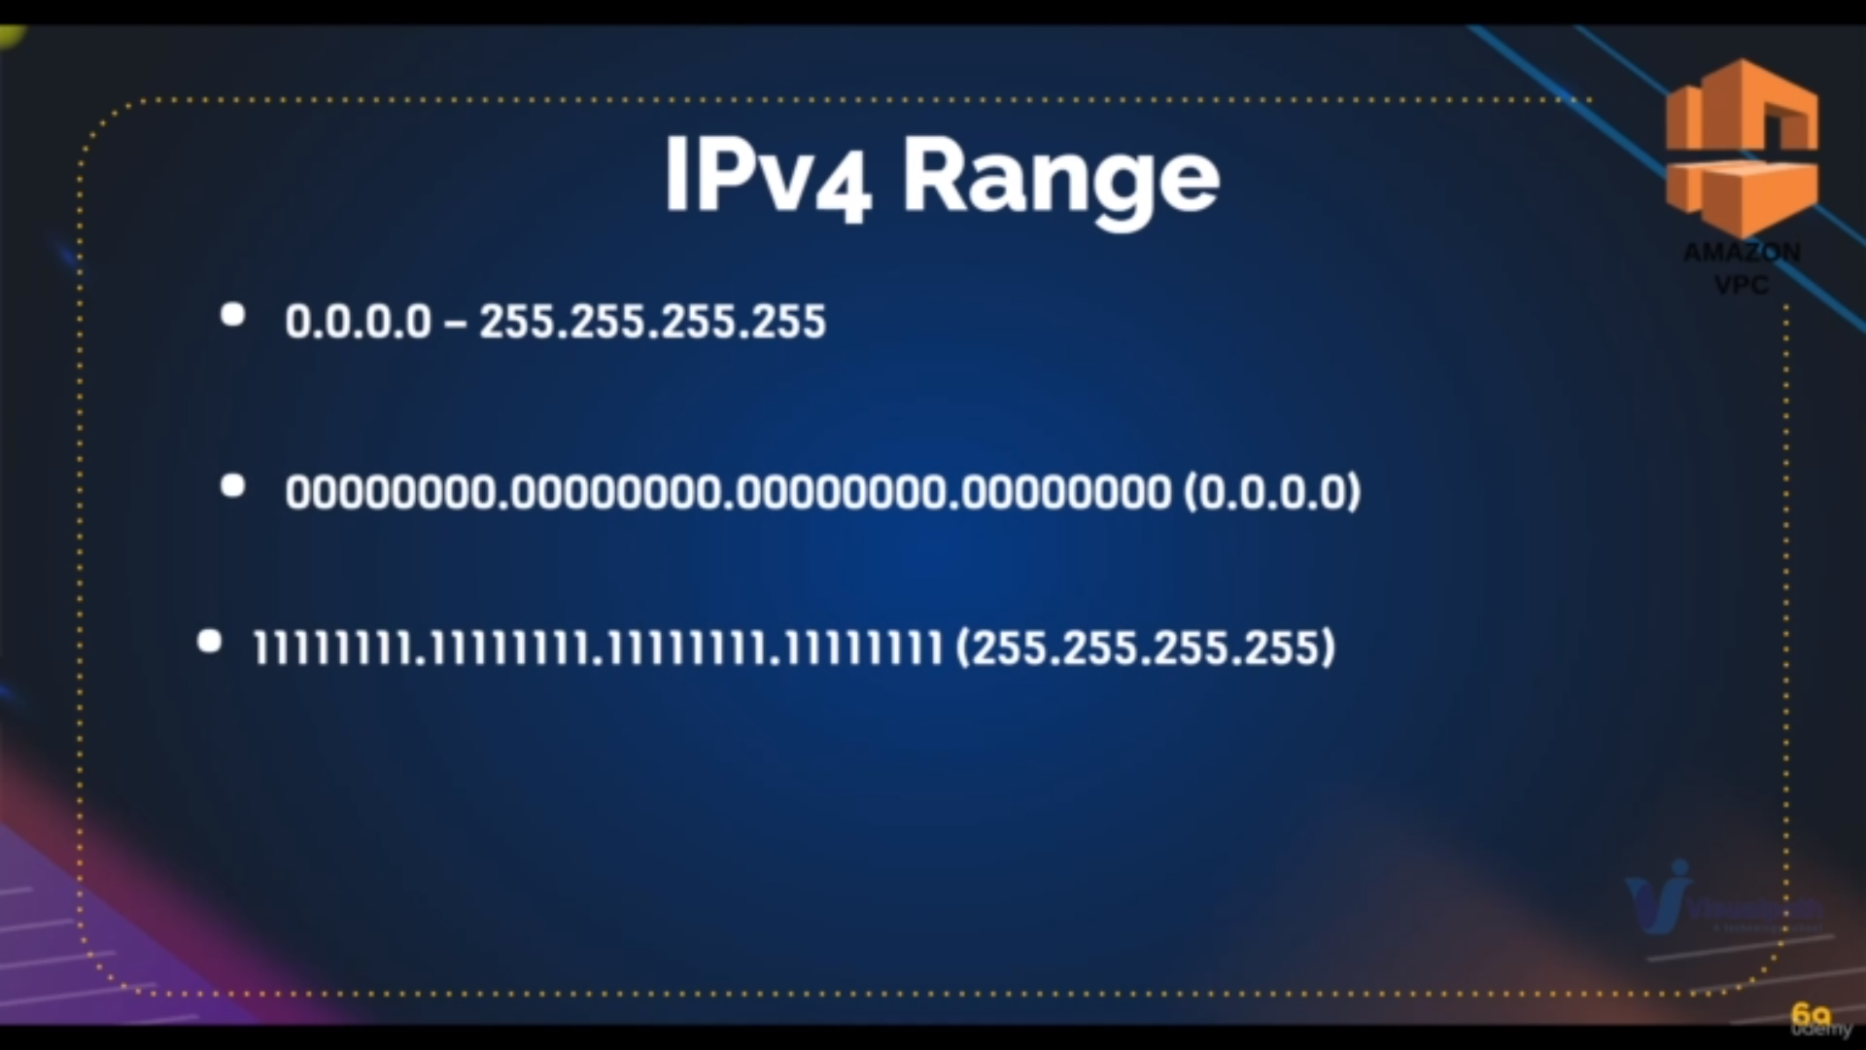ranges of ip

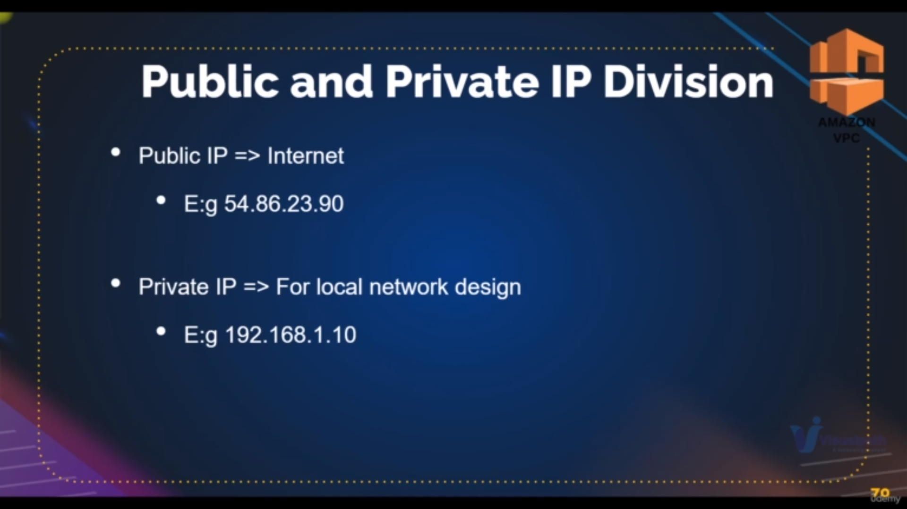public ip vs priavate IP

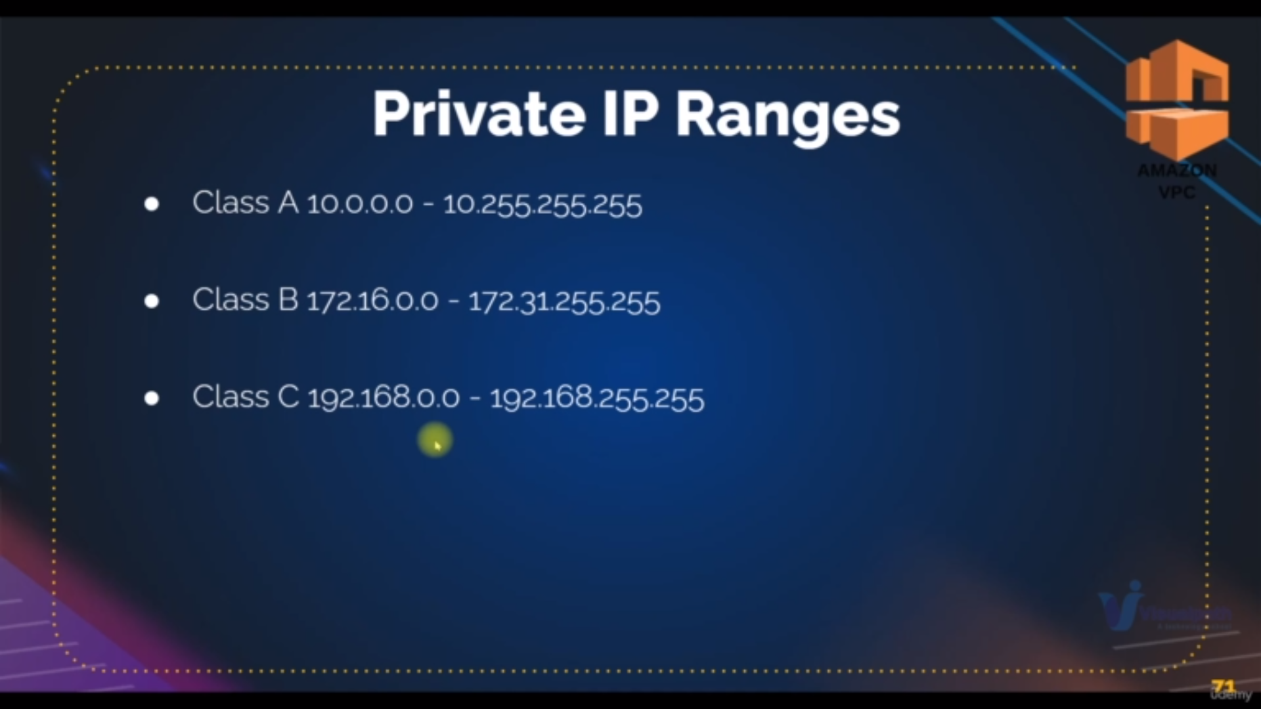private

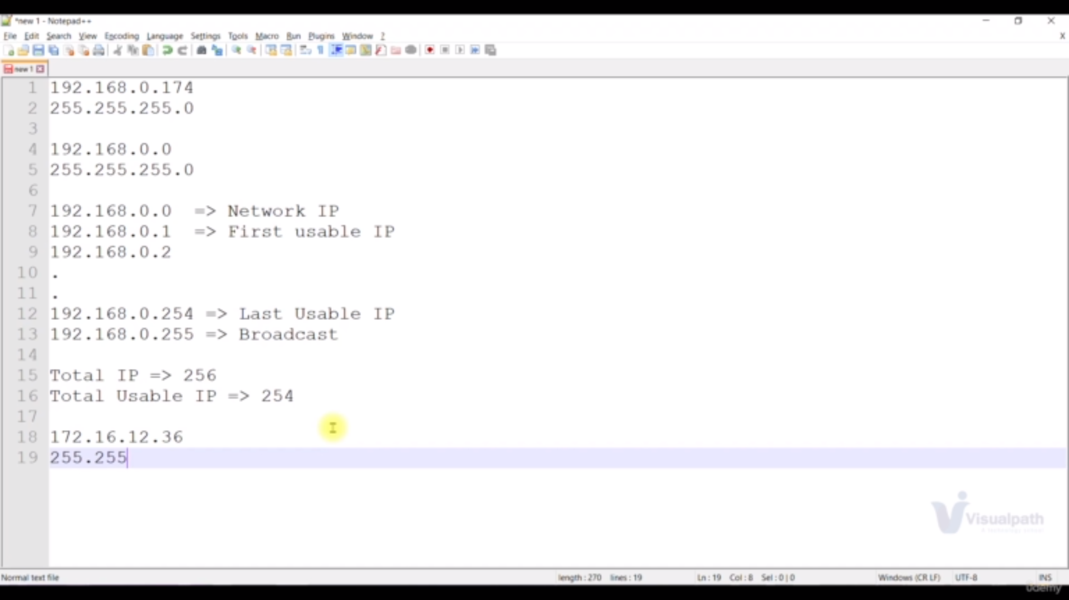as per the image if **subnet mask** is like **255.255.255.0** for an **ip 192.168.2.0**

since the **first there octets of subnet mask is 255.255.255** and **last octet is .0 .S**o **network ip is 192.168.2** and **host ip is .0**

**Note: we cannot change network ip but we can change host ip**

**some of the examples of ip adress:**

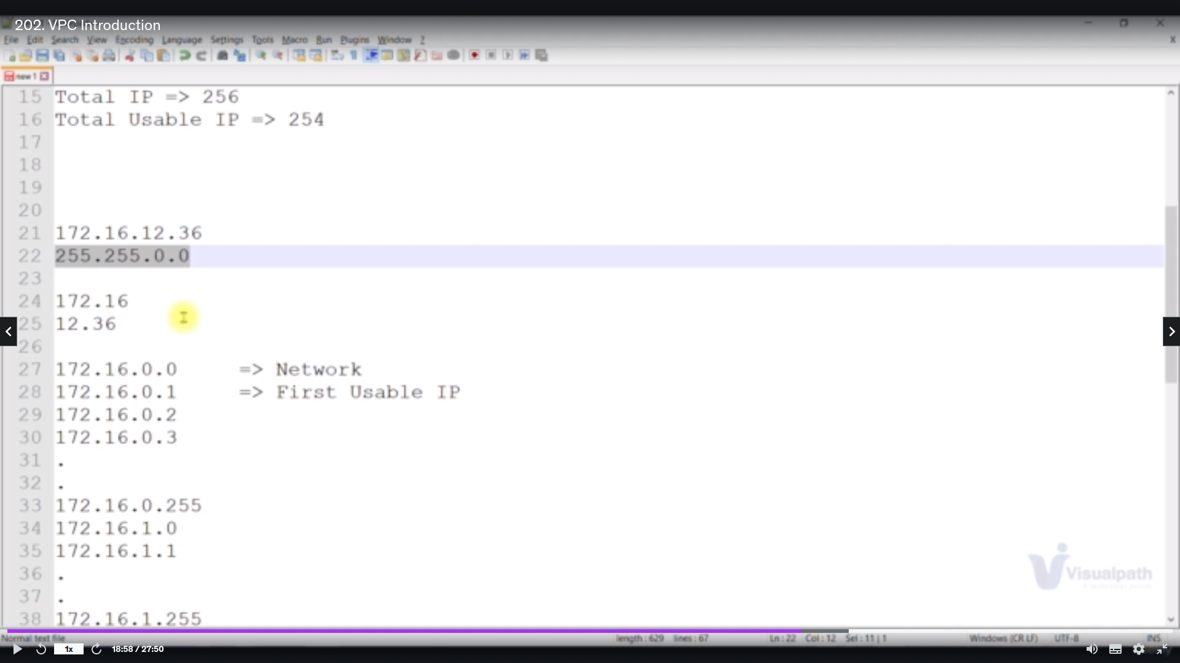**example2**

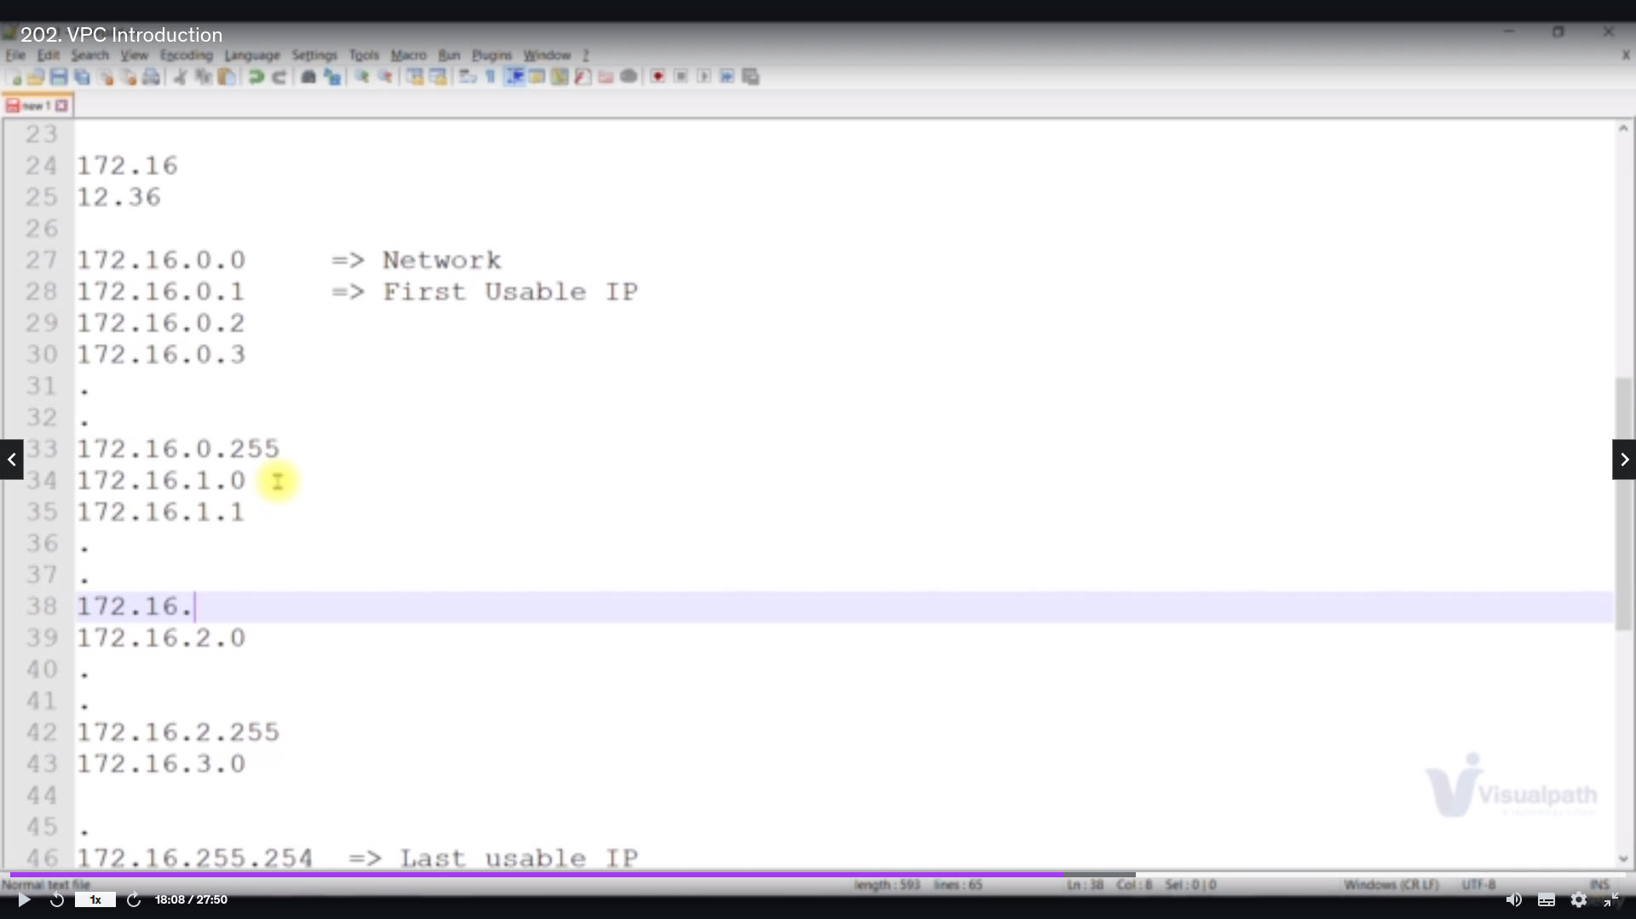**example2**

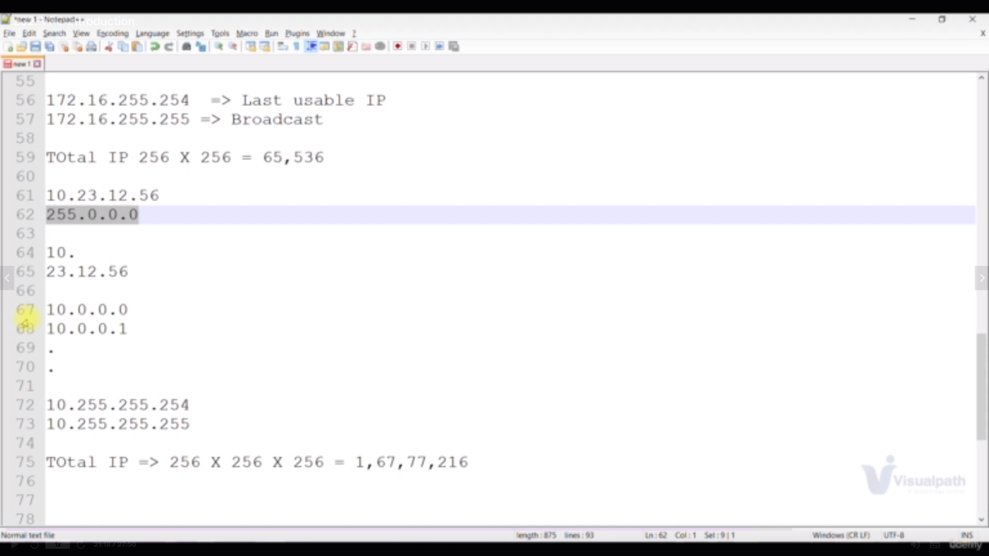**example3**

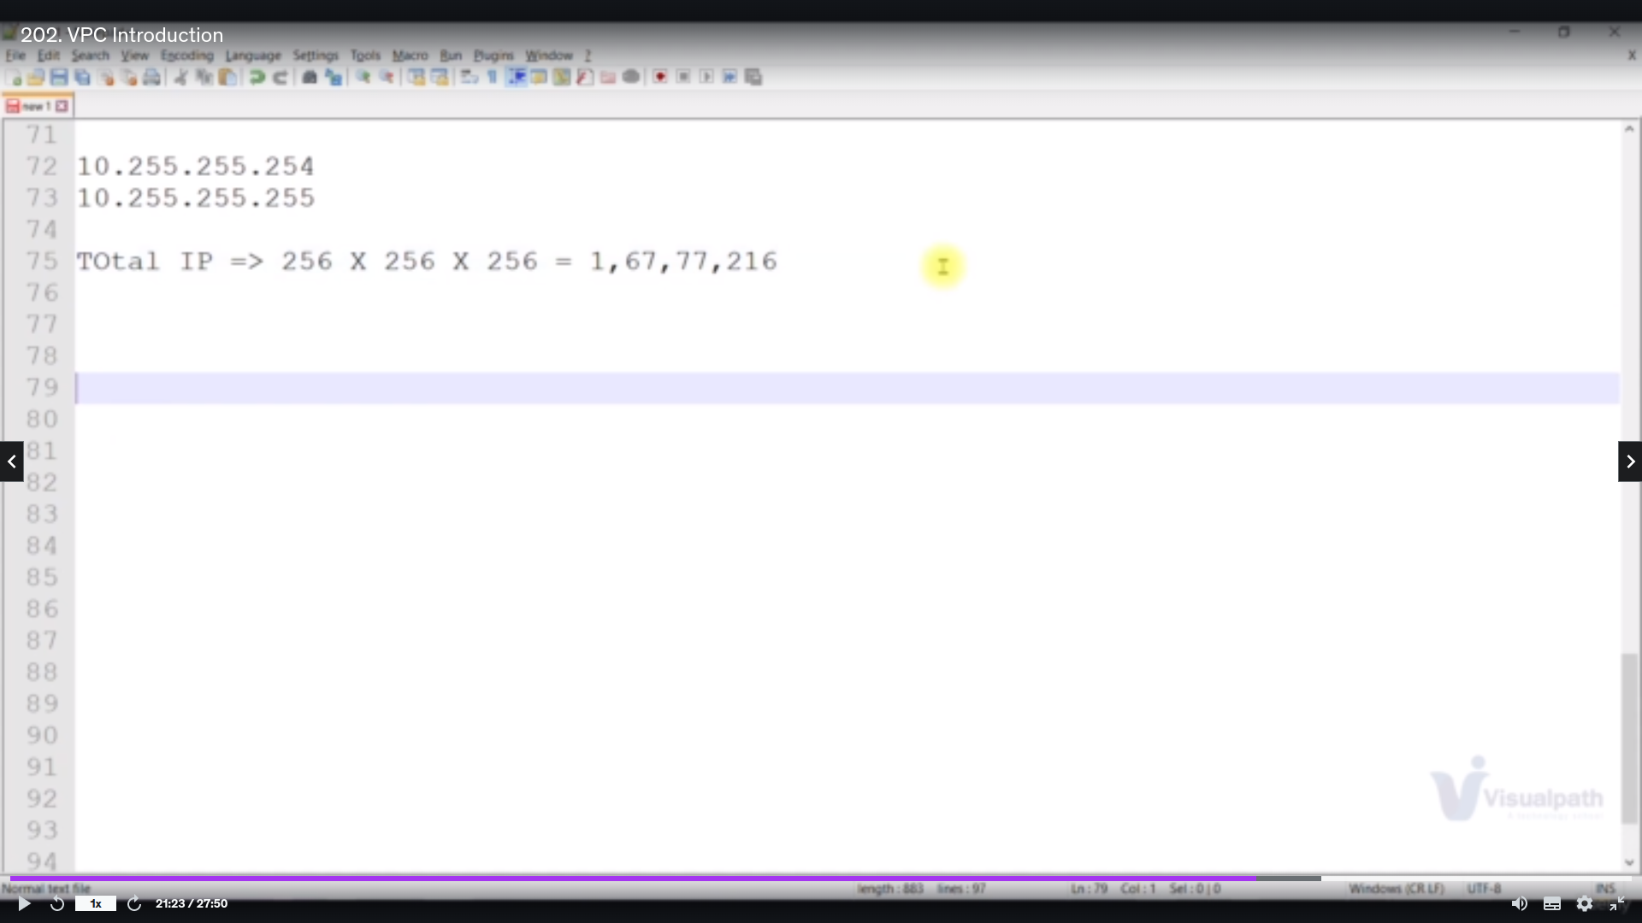**example3**

**CIDR Range:**

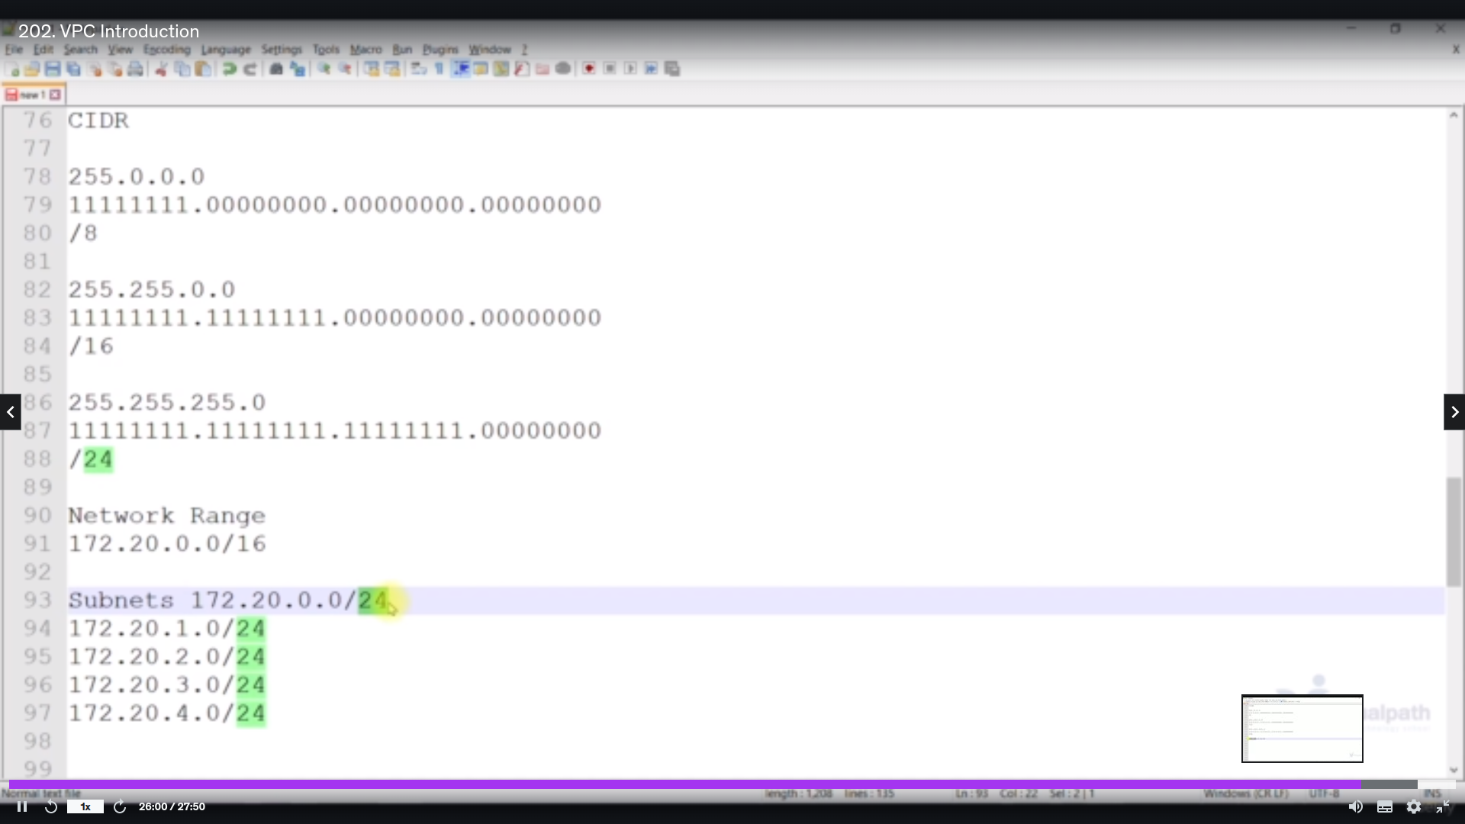as per image CIDR Range is nothing but subent mask but we will give in a

sidbar as shown in image

**Network range:**

**172.20.0.0/16**

**subnet1: 172.20.0.0/24**

**subent2: 172.20.1.0/24**

**---**

**---**

**---**

**–**

**subnet 256: 172.255.255.0/24**

by this we can create multple subnets in given CIDR Range

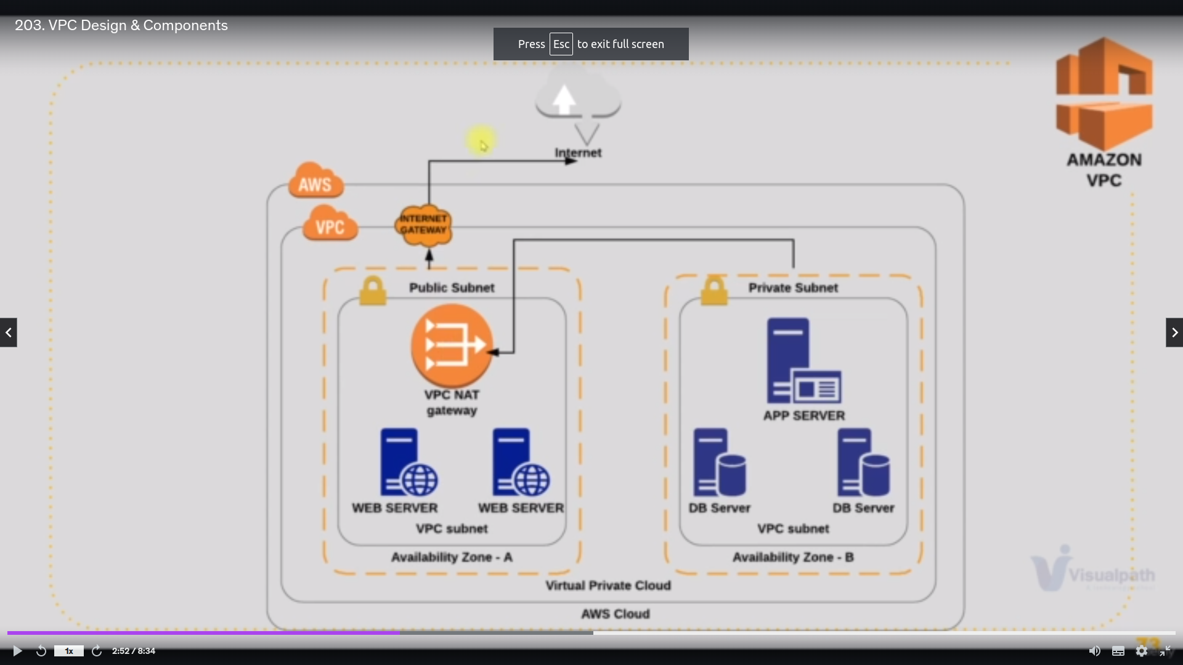Archetecture of VPC

**public subnet** can connected to internet through **Internet Gateway**

**private subent** can connected to internet or for public subent through NAT Gateway where it is maximum one way traffic for internet where private subnet can have the access to outside but not outside to privatsubnet

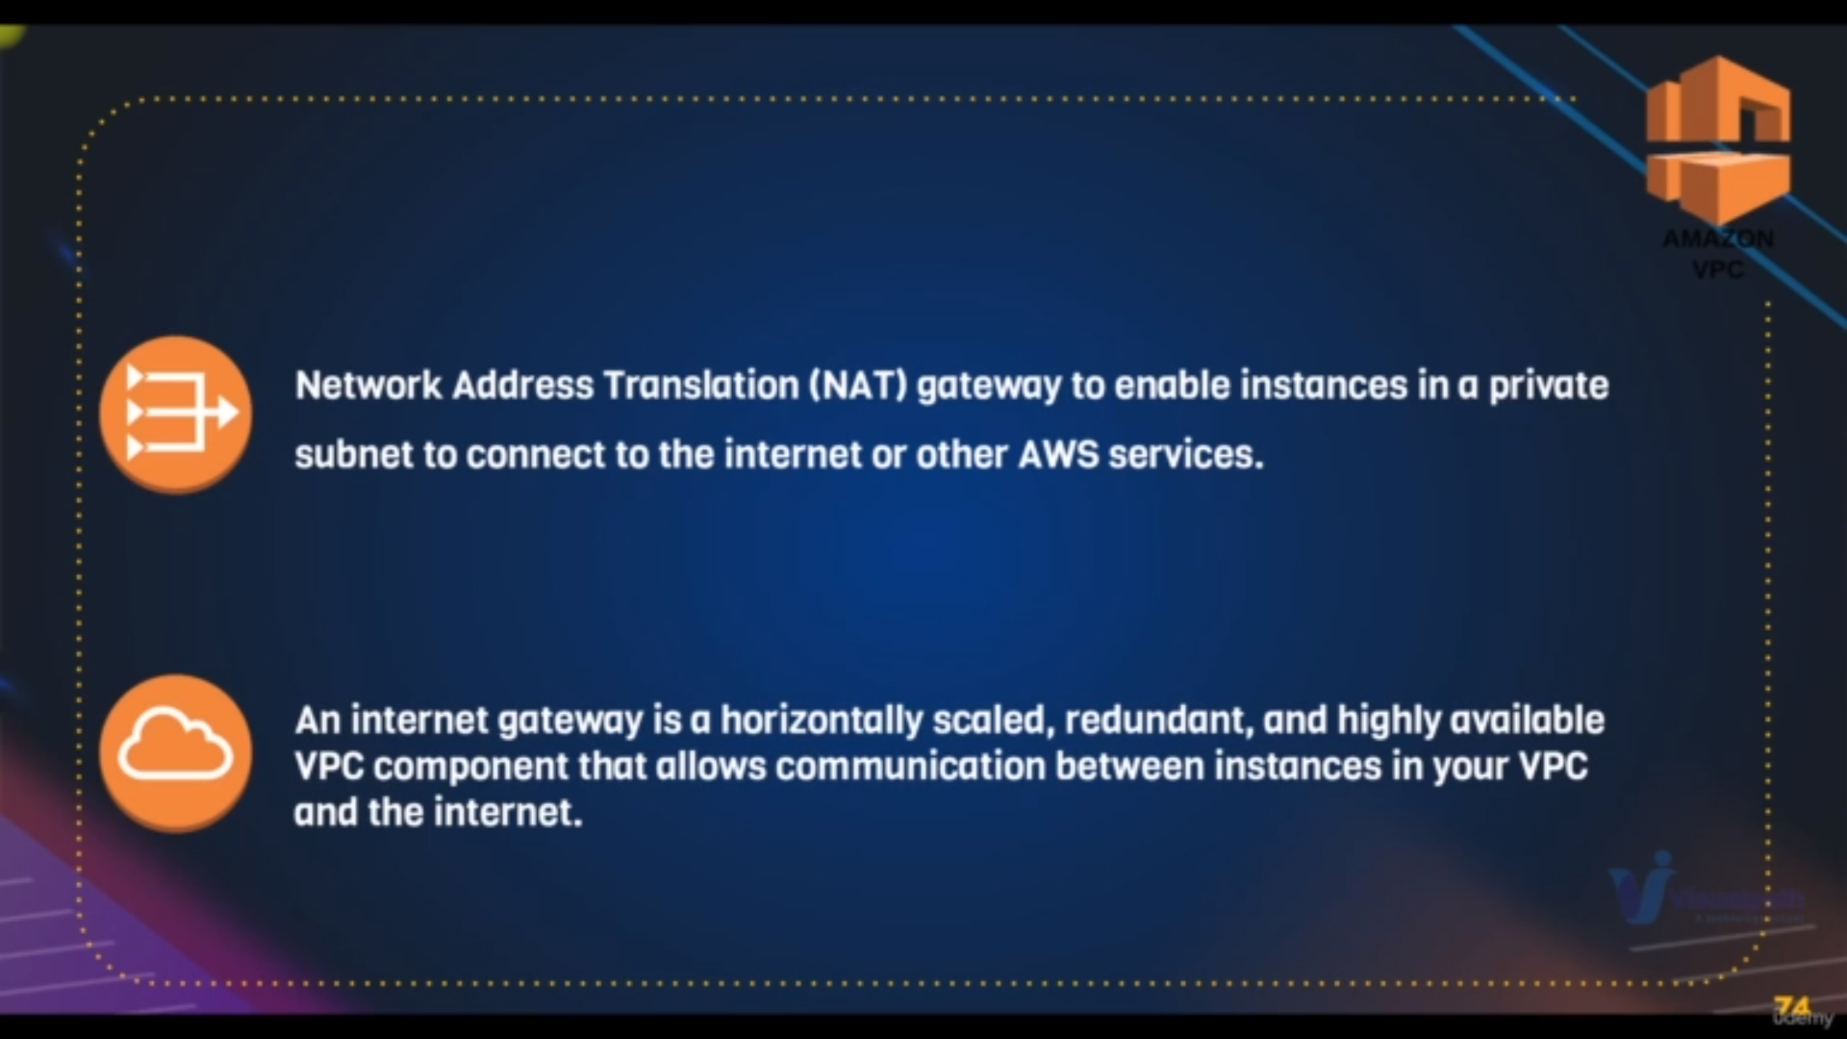defining internet gateway and NAT gateway

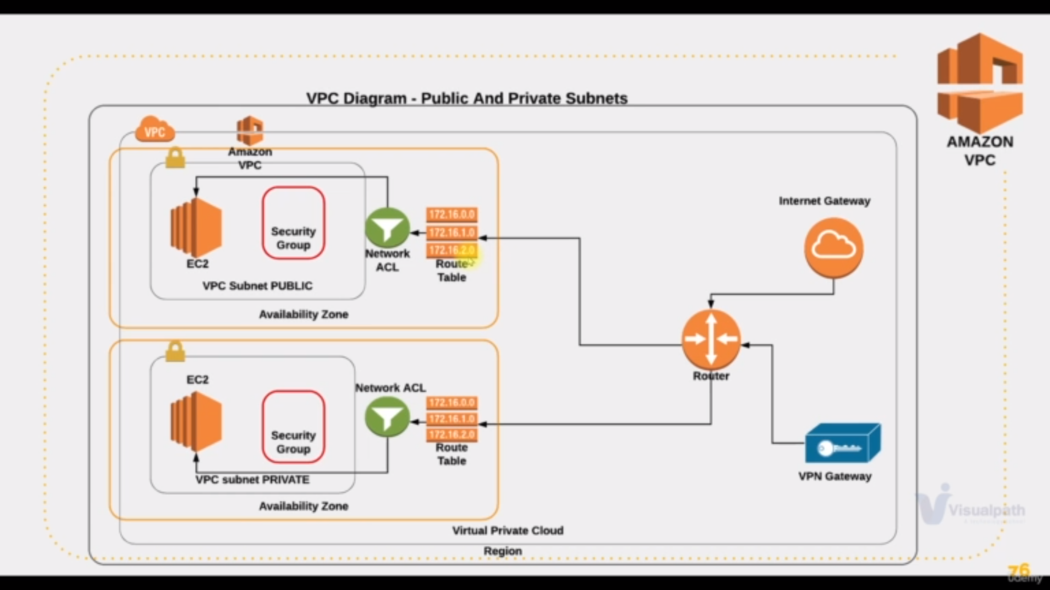for a ec2 instance we have **security groups** so to manage that we need a

**router** in vpc

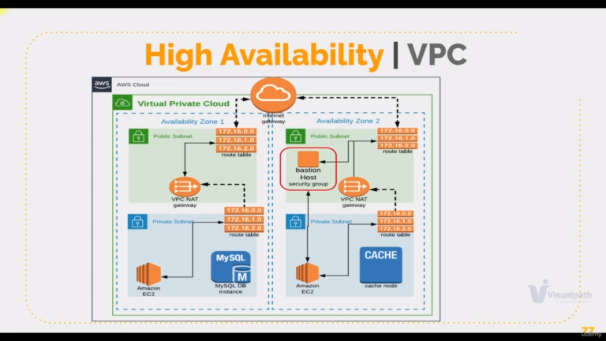we create multiple private and public subnet in different avalaibility zones

because if one goes down other will take charge to do tasks or services

**VPC cloud SetUp**



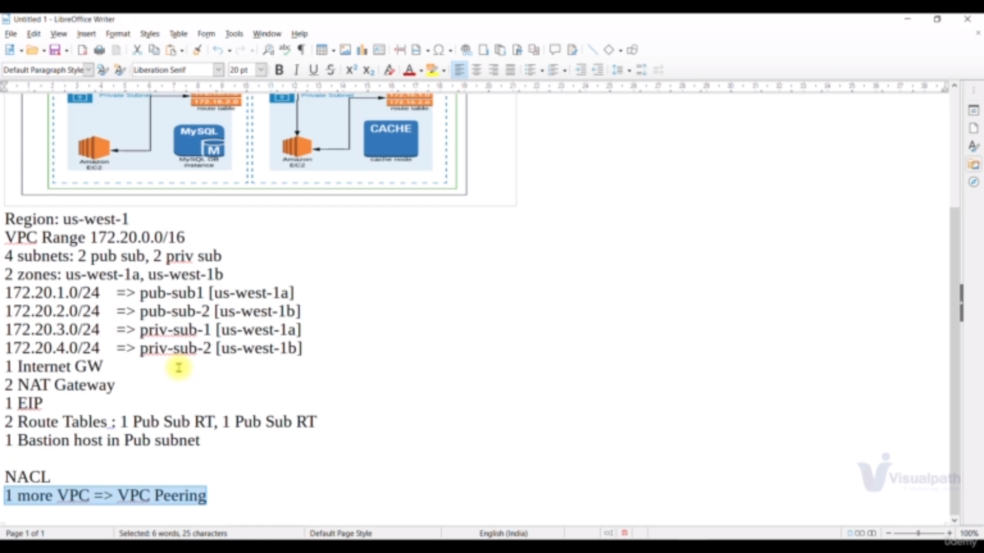**img : b**

**easiest way is that click on Vpc Dashboard→ launch vpc wizard**

**Step1:creata a vpc**

a) click on create vpc

b)give the name for vpc in name section

c) give the **cidr range or vpc range** that stated in **img b**

d) click on create

**step2:creating four subnets**

a) on left panel of vpc click on subnets

b) click on create subnets

c) select the above created vpc in step1

d)give the **subnet name ,cidr range,Availability zone** as per the **img b**

e) repeat the step2 for four subents [note : you can also add four subnets at a time by click on add another subents]

**step3:creating and atthaching internet gateway**

a) on left panel of vpc click on internet gateway

b) click on create internet gateway and give the name and click on create

c) on left panel of vpc click on internet gateway

d) select your internet gateway

e) click on actions

f) click on **attach to vpc** and select your vpc and click on attach

**step4: attaching the public subnets to route table or giving public subnets internet access**

a) on left panel of vpc click on route table

b)click on create route table and give the name, select vpc and click on create

c) on left panel of vpc click on route table and select your route table

d) click on **subnet assosciation tab** and edit subnet assosciation and select and add your public subnets

c) click on **routes tabs** and edit routes with the 0.0.0.0/0 as destinatinationa and internet gateway as target

**step5: creating the Nat-Gateway**

a) on left panel of vpc click on NAT Gateway

b)click on create and give the Name

c) select the subnet that NAT Gateway is to be placed

[Note: **NAT Gateway must be in public subnet]**

d) select your **elastic ip** or allocate a new elastic ip and select it

e)click on create

**step6: attaching the private subnets to route table or giving private subnets NAT Gatway access**

a) on left panel of vpc click on route table

b)click on create route table and give the name, select vpc and click on create

c) on left panel of vpc click on route table and select your route table

d) click on **subnet assosciation tab** and edit subnet assosciation and select and add your private subnets

c) click on **routes tabs** and edit routes with the 0.0.0.0/0 as destinatinationa and NAT gateway as target

**step7: getting public ip for instances in public subnets**

a) click on your **public subnet →** action→ Modify auto-assign-ip

b) check the box of **enable auto assign ipv4 adress** and save it

Note: repeat the same step for second public subnet also

**step8:getting DNS Names**

a)click on your **VPC**→ actions→edit DNS hostnames

b) check the box enable DNS hostnames and save it

**Using VPC:**

**setuping the requirements for vpc using:**

**step1:launch the instance or web server in private subnet**

a)launch a instance with

configuaration:

centos 7,

above vpc ,

above private subnet and also

user data for web service

**step1:launch the instance or web server in private subnet**

Since we dont have communication for above instance becos of privare subnet1172.20.0.0

we launch another instance as Baston/jumping server

a)launch a instance withconfiguaration:

amazon linux [in realtime cis amazon linux],

above vpc ,

above public subnet ,

sg group [allow ssh to myip]

**step3: copying the pem file make connection b/w baston and webserver**

By this Baston/jumping server

a)we first copy the pem file of websserver to Baston server f

b) we ssh connect to baston server

c) from there we ssh connect to webserver using pem

**Note**:first we have to make webserver **security group allow the Baston server**

**Step4:creating load balancer**

a) cick on create load balancer → select classing load balancer

b) write the load balancer name

c) slect your vpc

d) select public subnets where you want to launch the load balancer

e) click on next and make sure 80 is allowed in security group

f) click on next until **Add Ec2 instance** where select your **webserver** and click on create

**Note**:first we have to make webserver **security group allow the load balancer**

**-------------------------------------------------------------------------------------**

**end of setup**

**______________________________________________________________________**

**VPC peer to peer Connection:**

this is generally used whenever we want to communication with another vpc

**vpc to vpc communication**

**step1:creating request to anoher vpc**

a)on left panel of vpc click peering connection

b) click create peering connection

i)give the name

II) select our vpc which request for connection

iii)select region and account of another vpc

iv)give the vpc id of other vpc which we want communication

**From another vpc accept it**

**step2:Update the route table of subnet on bothside**

In our vpc

a) edit the routtable as

Destionation:other vpc cidr range

taget:your peering connection

do as it is another vpc but destination is viceversa